TIMETABLE OF MUSIC GROUPS 2017– 2018 

 | lunch | lunch | 3.35 – 4.45/5pm | Instrumental Lessons During School
 | Mu1 | Mu2
MONDAY   |  |  |  | Keyboard, Sax, Clarinet, Piano  Mrs. Foster  Flute – Mrs. Bundy
TUESDAY   | closed | FULL CHOIR  New members welcome
WEDNESDAY   |  |  | BAND when required  Show rehearsals | Keyboard, Sax, Clarinet, Piano  Mrs. Foster  Drum Kit – Mr. Weston
THURSDAY  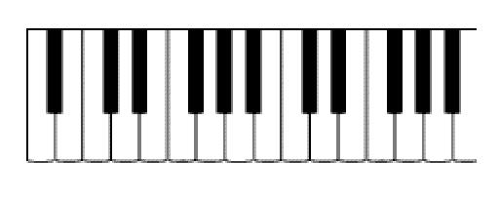 |  | Liturgy Prep.  Choir as requested |  | Voice – Mrs. Parker  Brass – Mr. Drury  Violin – Mrs. Cooper
FRIDAY   | GCSE and A Level coursework and full use of facilities  Available most days except Tuesday | GCSE and A Level coursework and full use of facilities.  Available most days except Tuesday |  | Guitar – Mr. Pollard

Pupils having music lessons may come and go as they please to check times on the noticeboard in the Music block.
Other smaller groups will rehearse as and when necessary around this timetable.
All pupils are reminded of the need to leave rooms tidy and to treat equipment with care and attention.

